< 김대균의 Tycoon 토익 첫걸음 - 샘플강 >

[ LC 문제 풀이 – PART 1 ]

(샘플강의에서는 1번만 강의합니다.)
1.
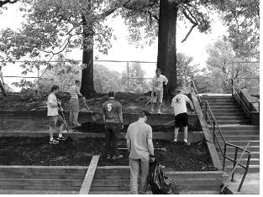

2.
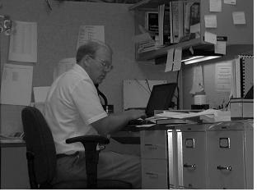

3.
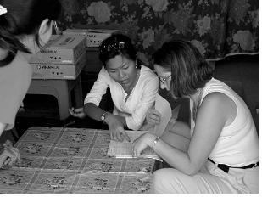

[RC 문제풀이 - PART 6]
Exercise 1
Questions 1-3 refer to the following letter.
Angelina Smith
Public Relations Representative
American Red Cross
2025 E Street, NW
Washington, DC 20006

I would like to obtain the name of the individual who is __________ for fund-raising for
1. (A) reliable
(B) worthy
(C) charged
(D) responsible
the American Red Cross.
I hope to start a career in fund-raising with nonprofit organizations. __________, I would
2. (A) Accordingly
(B) Inappropriately
(C) Reluctantly
(D) Subsequently
like to speak with someone who has already become a successful fund-raiser in a renowned organization such as the American Red Cross.
If you could provide me with the contact information for _________ an individual, I would
3. (A) so
(B) such
(C) like
(D) very
be most grateful.
Thank you for your time. I look forward to your reply.

Sincerely,
Nick Helm

Exercise 2
Questions 1-3 refer to the following advertisement.
The secrets of coffee revealed! Just pop in the Café Kaffei’s World of Coffee DVD.
Through the award-winning Café Kaffei DVD, you can ______ the secret of what makes
1. (A) discover
(B) ignore
(C) show
(D) originate
a superb cup of gourmet coffee.
Sit back and watch as professionals guide you through all that goes into making __________ coffee.
2. (A) except
(B) exception
(C) exceptional
(D) exceptionally
Expert explanations will show you how to __________ the taste and aroma of the world’s most
3. (A) calculate
(B) overlook
(C) measure
(D) evaluate
popular coffees.
From the growing of the beans to the brew in your cup, you will learn everything you need to know to become the ultimate coffee connoisseur!

Order your copy now!

< 정답 >

[ LC 문제 풀이 – PART 1 ]

1. B
2. A
3. B

[ RC 문제 풀이 – PART 6 ]
Exercise 1
1. D
2. A
3. B

Exercise 2
1. A
2. C
3. D

TOEIC VOCABULARY for Kim Dae Kyun's Students

back up * computing a copy of information on your computer that you make
in case you lose the information 저장하다
ex) Remember to do regular backups

at ease * confident and relaxed 마음 편히
ex) He was more at ease in the classroom than on a political platform

split * to divide or break something into several parts 쪼개다
ex) Just split the cake into three and leave one piece for Simon
* To share something by dividing it into separate parts 나누다
ex) I split my working hours between three offices

accessible * an accessible place is easy to find or get to 접근하기 쉬운
ex) The city is easily accessible by road train or air

quantity * the amount of something 양
ex) They monitor both the quantity and the quality of materials used

quality * The quality of something is how good or bad it is 질
ex) This cut in funding will adversely affect the quality of education in our school

exquisite * extremely beautiful and delicate 정교한
ex) An exquisite hand painted vase from china
* Showing excellent judgment 훌륭한
ex) The furnishings show exquisite taste

disassemble * to take something apart in order to repair it or understand how it works 분해하다

inquiry a question intended to get information about someone or something
문의
ex) There have already been over 300 inquiries form people interested

taper off * to gradually become less 서서히 줄어들다
ex) Spending has tapered off from $844 million to $ 557 million

