< 김대균의 Tycoon 토익 첫걸음 – Lesson 38>

[FINAL TEST] PART 4

77. How many times has Samantha left a message?
(A) Once
(B) Twice
(C) Three times
(D) Four times

78. What is the purpose of Samantha’s message?
(A) To meet with a German client
(B) To ask about his daughter’s recital
(C) To change the date of their meeting
(D) To find out if Dennis has a ring for her

79. What does Samantha request Dennis to do?
(A) To call her back the next day
(B) To meet with the new clients from Germany
(C) To cancel the negotiation agreements
(D) To invite her to his daughter’s dance performance

80. Who is Clarence Michaels?
(A) A treasure hunter
(B) A manager at Birmingham
(C) A school principal
(D) A professor

81. When was the book written?
(A) One year ago
(B) Three years ago
(C) Twelve years ago
(D) Forty-five years ago

82. What facility was the study done at?
(A) At a wasteland
(B) At Amherst College
(C) At Birmingham Waste Management Facility
(D) At the gas refinement facility

83. What is going to be held?
(A) A riot
(B) Tourism
(C) A stage performance
(D) A film exhibit

84. When are the tickets expected to sell out?
(A) By the 8th
(B) By the 9th
(C) By the 14th
(D) By the 22nd

85. What have the workers begun to do?
(A) Set up stage equipment
(B) Build the stadium
(C) Rehearse their music
(D) Act as tour guides

<정답>

77. B
78. C
79. A
80. D
81. B
82. C
83. C
84. D
85. A

[FINAL TEST] PART 7

Questions 173-176 refer to the following notice.
Key Cycle’s new employee-award program

Key Cycle introduces its first employee-award program. At Key Cycle, we pride ourselves on the ability to provide excellent customer assistance 365 days a year. The purpose of this employee-award program is to pay tribute to the employee who has consistently provided the best customer service
throughout the year.

At the end of every month, survey forms will be available for customers to fill out during check-out and drop off in a big blue bin in front of the two exits. After twelve months, these blue bins will be opened by members of the management department who will read and access the customers scores and comments to rank employees on overall friendliness and helpfulness.

One winner will be announced at our end of the year party, and he or she will receive one week’s paid leave and a gift certificate for two to Aquagene Spa. To be eligible, the employee does not have to be full-time, but must have been working with Key Cycle for at least one year. Any employee who is caught dropping off a survey form or coercing a customer into completing a form will be fired without compensation. For all other questions, please forward by phone to Sue Henry at the head office.

173. What is the purpose of this notice?
(A) To explain a new exiting procedure
(B) To notify employees about the importance of survey forms
(C) To help customers with their shopping
(D) To announce the launch of an employee-award program

174. When can customers complete forms?
(A) During the manager’s meeting
(B) While they talk to the employees
(C) During their purchase
(D) Before they enter the store

175. What is awarded to the winner?
(A) Time off from work
(B) Promotion to the management department
(C) A congratulatory tribute
(D) Flight tickets for two

176. According to the notice, which is NOT the right information?
(A) The forms must be filled out by customers.
(B) The forms will reflect employee service to customers.
(C) The forms will be stored in a blue box.
(D) The forms must be mailed to the reception desk.

<정답>

173. D
174. C
175. A
176. D

Questions 177-180 refer to the following article.
Supreme Court Justice, Anna Shirley made public today her three year long battle with breast cancer. Shirley was appointed to the Supreme Court nineteen years ago by the late Justice Theodore Morris who died early last year.

Her latest chemotherapy treatment forced her to miss yet another important case and the judiciary board was not pleased. Rumors are abuzz that Shirley is being pressed to officially announce her retirement within this year regardless of the outcome of her medical treatment. A spokesperson for WAC, Women Against Cancer, is organizing a protest in Shirley’s behalf to defend her right to remain on the board whether or not her treatment is successful. WAC has also claimed that Shirley will speak at their annual convention in Washington this September but Shirley’s representatives have denied that claim.

Anna Shirley’s sudden announcement today caught many off guard. Her bout with cancer has been a secretive, unnoticed one even for other members of the Supreme Court. It is only recently that signs of the cancer have begun to show, prompting questions and suspicions about her mysterious absences from several headlinegrabbing cases earlier this year.

177. What is the article mainly about?
(A) The Supreme Court
(B) Women Against Cancer (WAC)
(C) Justice’s announcement of her illness
(D) A September convention in Washington

178. What is stated about the influence of Anna Shirley’s medical treatment?
(A) It was unsuccessful.
(B) It will force her to resign from the Supreme Court.
(C) It left many visible signs on her.
(D) It did not allow her to attend to her job.

179. What does the article say about the convention?
(A) Shirley will speak at it this September.
(B) It was organized by the Supreme Court.
(C) Shirley’s representatives will bring her.
(D) It will protest on Shirley’s behalf.

180. When did symptoms of the cancer start to become visible?
(A) This September
(B) Earlier this year
(C) Three years ago
(D) Nineteen years ago

<정답>

177. C
178. D
179. D
180. B

TOEIC VOCABULARY for Kim Dae Kyun's Students
indicative adj 암시하는, 나타내는
▶ showing that something will happen, is true, or exists
ex) These latest figures are indicative of a slowing economy.

instigate verb 시작하다, 자극하다
▶ to make something start, especially an official process
ex) The leaders of the two factions instigated peace talks.

adjoin verb 인접하다
▶ to be right next to and connected to another building, room, area
ex) The land that adjoins the park.

land verb 도착하다, 착륙 시키다, 획득하다, 찾아내다
▶ to arrive at a place by plane or boat
ex) It was after midnight by the time we landed.
▶ if an aircraft lands, it comes down to the ground
▶ to get something that you wanted especially a job or opportunity
ex) At age 19 she landed a small role in a Broadway play.

momentary adj 일시적인, 순간의, 찰나의
▶ lasting for only a very short time
ex) There was a momentary silence.

catch on vb 유행하다
▶ to become popular or fashionable
ex) Sports drinks have caught on as consumers have become more health-conscious.

incinerate verb 태우다
▶ burn something completely

affordable adj 적당한 가격인
▶ inexpensive enough for ordinary people to afford
ex) affordable housing
ex) concert seats at affordable prices

김대균의 SWT 속으로
[Question 1-5: Write a sentence based on a picture]
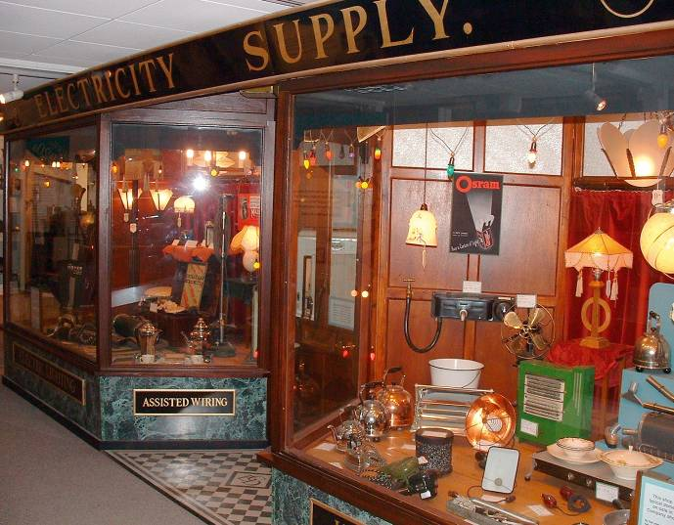
display, merchandise

[Lower level] The merchandise is displayed.
[Mid level] Merchandise is on display in the window.
[Higher Level] A variety of merchandise has been displayed in the shop window.

- Writing Test
[Questions 6-7: Respond to a written request]
[Question 6]
Read the e-mail below and write an e-mail that responds to the information. Respond as if you are a sales associate. In your e-mail to the Director of Sales, make at least TWO proposals.
-------------------------------------------------------------------------------
From: Mark Edwin, Director of Sales
To: All Sales Associates
Subject: Meeting
Date: April 15, 2:23 P.M.

Good afternoon everyone. The weekly meeting scheduled for Thursday morning has been postponed because the Maintenance Department decided to fix the overhead lights in the conference room. If anyone has suggestions about when to hold the next meeting, please email me by 6 P.M. today.

