< 김대균의 Tycoon 토익 첫걸음 – Lesson 30>

[FINAL TEST] PART 1

1.

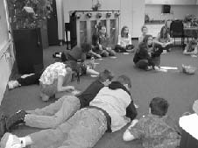

2.

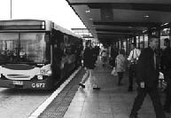

3.

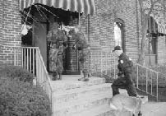

4.

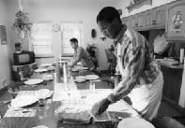

5.



6.



7.

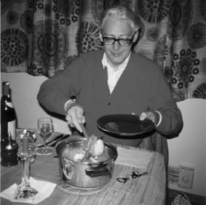

8.

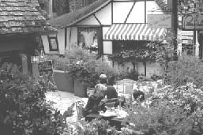

9.

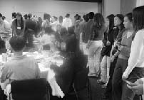

10.

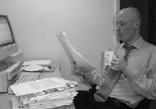

< 정답 >

1. A
2. C
3. B
4. D
5. A
6. A
7. C
8. D
9. B
10. D

TOEIC VOCABULARY for Kim Dae Kyun's Students

further adv추가적인
▶ used for talking about an additional thing or amount
ex) No further steps have been taken to avoid the crisis.
ex) Further information is available from the secretary.
until further notice 추가적인 통보가 있을 때까지

affectionate adj 애정어린
▶ showing that you love or care about someone or something
ex) My best friend is thoughtful and affectionate.

rear = rear up verb 사육하다, ~를 기르다
▶ to take care of a child or young animal until it is fully grown
ex) Most farmers in the area rear sheep.

patent noun 특허증, verb 특허를 얻다, adj 명백한, 분명한
▶ an official document that gives someone who has invented something the legal right to make or sell that invention for a particular period of time, and prevents anyone else from doing so
ex) In 1878, Edison received a patent for his phonograph.
▶ to get a patent for something
ex) When was the first computer mouse patented.
▶ extremely obvious
ex) His comments are just patent nonsense.

compile verb 편집해서 하나로 만들다
▶ to make something such as a list or book by bringing together information from many different places
ex) The database was compiled from statistics published by the Tourist Board.
be compiled into 편집되어 하나가 된

compatible adj 와 어울리는
▶ ideas or systems that are compatible can exist together
▶ the proposed new regulation is not compatible with our existing policy
be compatible with ~와 어울리는

seasoned adj 경험많은, adj 양념된
▶ experienced in a particular activity
ex) a seasoned traveler
▶ containing seasonings to improve flavor

geek noun 괴짜, 광
▶ someone who is boring especially because they seem to be interested only in computers

김대균의 SWT 속으로

[Questions 7-9: Respond to questions using information provided]
Question 9: Could you tell me about the voting schedule?

- Sample Response - Higher Level
The entire voting schedule takes one hour, with a different topic being voted on every 15 minutes.
At 5:00 P.M. the community will vote on whether or not to renovate the Public Library. Next, the community will vote on implementing a breakfast program at a local elementary school. Then, they will vote on building a recycling facility. After that, the community will vote on building a community pool.
Finally, the community will vote on raising property taxes.

Question 9
Could you tell me about the voting schedule?

Sample Response
The entire voting schedule takes one hour, with a different topic being voted on every 15 minutes. At 5:00 P.M. the community will vote on whether or not to renovate the Public Library. Next, the community will vote on implementing a breakfast program at a local elementary school. Then, they will vote on building a recycling facility. After that, the community will vote on building a community pool. Finally, the community will vote on raising property taxes.

