< 김대균의 Tycoon 토익 첫걸음 – Lesson 2 >

[PART 1] 8개의 이야기

1. 움직이는 사람들

1.
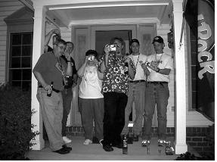
2.


2. 어떻게 생겼나?

1.
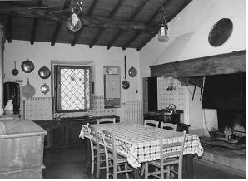
2.


3. 점점 길어지는 이야기

1.
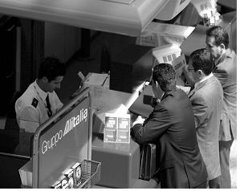

2.

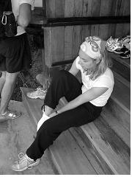

4. 누가 그랬는지는 몰라요

1.

2.


5. 왜 이걸 몰랐을까?
1.

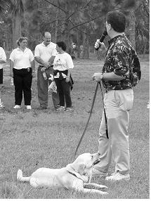
2.


[PART 5&6] 준비되셨나요? p.191~195

1. The tape recorder has a SPEED button that provides the user with ------- over the tempo at which the song is played.
(A) controlling
(B) control
(C) to control
(D) controlled

2. New playground equipment with improved safety features has been installed in ------- of the old and damaged swing set.
(A) placing
(B) placed
(C) place
(D) to place

3.The judge was in complete ------- with the mother in this case, and ruled that the child should not be sent to its grandparents.
(A) agreed
(B) agree
(C) agreement
(D) agreeing

4. ------- in emergencies can be obtained from organizations such as the Red Cross, the United Nations, or the Salvation Army.
(A) Assist
(B) Assistance
(C) Assists
(D) Assistant

5. The Tal-Mart Furniture Store offers a ------- of quality home furnishings including chairs, sofas, beds and tables.
(A) vary
(B) variety
(C) various
(D) varied

6. Many things should be considered by employees before making a relocation -------.
(A) decision
(B) decider
(C) decide
(D) deciding

7. Our company has issued a policy that states (that) every ------- must have an annual performance evaluation.
(A) employee
(B) employment
(C) employs
(D) employ

8. Now that he has graduated, he is interested in applying for a ------- in psychology at a small hospital in New Jersey.
(A) positioning
(B) position
(C) positioned
(D) positions

9. I have found that the librarian was quite helpful in ------- documents in the files or even on the Internet.
(A) locating
(B) located
(C) will locate
(D) to locate

10. Every decision about ------- a business alliance needs to consider the benefits of the new partnership as well as its limitations.
(A) to join
(B) join
(C) joining
(D) joined

< 정답 >

1. B
2. C
3. C
4. B
5. B
6. A
7. A
8. B
9. A
10. C

TOEIC VOCABULARY for Kim Dae Kyun's Students
relinquish * To give up your power , position, or an advantage especially when you do
not want to do this 포기하다
ex) She was forced to relinquish her leadership.

expertise 전문지식
* Special skill or knowledge that you get from experience, training or study
ex) Technical professional medical expertise.

initiative 독창성
* The ability to decide in an independent way
what to do and when to do it
ex) Mr. Hills showed initiative and bravery when dealing with a dangerous situation.

slash 삭감하다
* Mainly journalism to reduce something by a large mount
ex) Congress voted to slash funds for several domestic programs.

authorization 허가
* Official permission to do something
ex) The action was taken without the authorization of the leadership.

saturation 포화상태
* a situation in which something is so full of a particular type of thing that nothing more can be added
ex) indications that the market has reached saturation

landed 얻은 획득한
* including or relating to a large area of land with one owner
ex) a landed state

certificate 자격증
* An official document or record stating that particular facts are true
for example a birth certificate gives the official facts about your birth and a health certificate gives the facts about your state of health

afford 감당하다
* If you can afford something you have enough money to be able to pay for it
This word always follows “can” or ”could”
ex) We need a bigger house but we just can’t afford the rent.

dilapidated 황폐한
* A dilapidated building, vehicle, or system is old and in bad condition

김대균의 SWT 속으로
- Speaking Test
[Questions 1-2: Read a test aloud]
Directions: In this part of the test, you will read aloud the text on the screen. You will have 45 seconds to prepare. Then you will have 45 seconds to read the text aloud.
This message is for all marketing associates planning to attend this year’s company picnic.

This message is for all marketing associates planning to attend this year’s company picnic. Our department has been assigned the very important task of providing dessert for the special occasion. A sign-up sheet has been placed in the break room, and everyone is kindly asked to write down a dish that they will bring on Sunday. To make things easy, please write down your name, the name of the dish, and how many servings you plan on bringing. Also, please read the list carefully and avoid writing down something that has already been chosen. The last thing we want is fifty plates of double-chocolate-fudge brownies!

- Speaking Test 훈련
1. 자신 있게 읽자!
발음에 자신이 없더라도 성의껏 정확하게 읽어 나간다.
2. 서두르지 말자!
차분하게 자신의 색깔대로 읽어 나간다.

