< 김대균의 Tycoon 토익 첫걸음 – Lesson 3 >

[PART 1] 8개의 이야기

6. 이렇게 깊은 뜻이?

1.
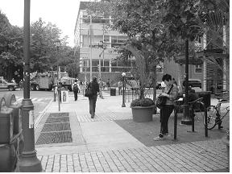

2.
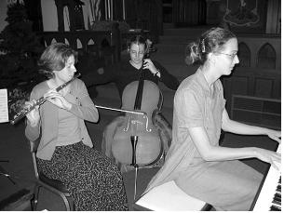

7. 왜 내 마음을 어지럽히니?

1.
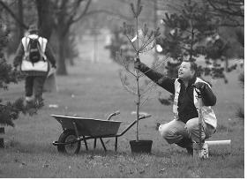
2.
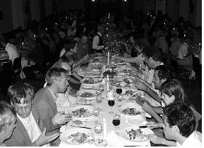

8. 배경도 중요해요.

1.
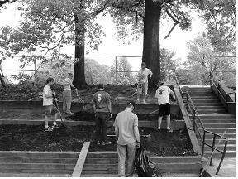
2.
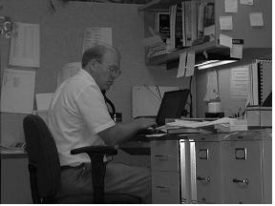

[PART 1 ] Mini-Test

1.
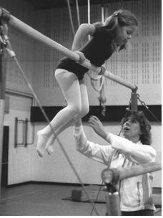

2.

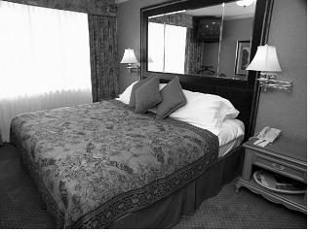

3.
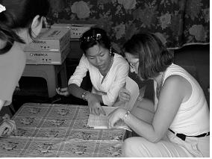

4.
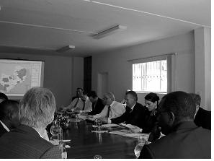

5.
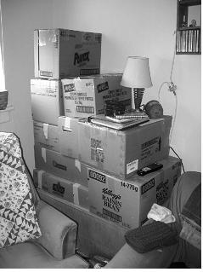

[PART 5&6] 준비되셨나요? p.196~199

1. His firm’s success is due to its flexible strategies and ------- cooperation with its
overseas partners.
(A) remarkably
(B) remarks
(C) remark
(D) remarkable

2. Even though the company posted ------- fourth quarter sales, there are still questions about its lawsuit with the government.
(A) impressive
(B) to impress
(C) impresses
(D) impress

3. International customers are ------- for any duties, taxes, or other charges assessed
on packages delivered outside of the U.S.
(A) responsibly
(B) responsibility
(C) responsive
(D) responsible

4. Negotiations were quite difficult as the directors were not at all ------- about saying
that they wanted to lay off staff.
(A) hesitancy
(B) hesitant
(C) hesitated
(D) hesitation

5. The newspaper said that the government remains ------- to raise tariffs on Chinese
goods if an acceptable agreement is not reached.
(A) readily
(B) readier
(C) ready
(D) readiness

6. Sending money overseas can sometimes seem ------- when you first encounter the rules of the International Banking System.
(A) confusion
(B) confuse
(C) confusing
(D) confusingly

7. There are many ------- things about owning your own business that most people do not think about when they start.
(A) surprising
(B) surprised
(C) surprise
(D) surprises

8. We refused delivery of our order and sent it back to the factory because all of the boxes arrived in ------- condition.
(A) damage
(B) damaged
(C) damaging
(D) damages

< 정답 >

1. D
2. A
3. D

4. B
5. C
6. C

7. A
8. B

LC 정복 - 영국식 & 미국식 발음 비교

1. The centerpiece has been placed on the table. 중앙부 장식이 탁자에 놓여 있다.
2. The table is covered with cloth. 탁자가 천으로 덮여 있다.
3. The dining table is in front of the fireplace. 식탁이 벽난로 앞에 있다.
4. Some buildings have pointy tops. 몇몇 건물들의 꼭대기가 뾰족하다.
5. The movie is being filmed. 영화가 촬영되고 있다.
김대균의 SWT 속으로
- Speaking Test
1. 사진의 종합적인 내용을 말한다.
2. 30초의 준비 시간+ 45초의 실제 읽는 시간
3. 단어 위주로 Speaking을 준비한다.

- [Question 3: Describe a picture]
Directions: In this part of the test, you will describe the picture on your screen in as much detail as you can. You will have 30 seconds to prepare your response. Then you will have 45 seconds to speak about the picture.
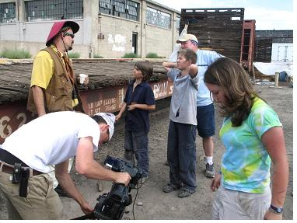

사진 속의 예상 어휘
people (사람들)
man (남자)
video camera (비디오 카메라)
children (아이들)
videotaping (녹화하다)
wearing a hat (모자를 쓰고 있는)

- Sample Response
There are people gathering next to a building. One man is holding a video camera. Three people are looking at a man wearing a hat and a girl is looking at the ground. The man is wearing the hat. It looks like they are videotaping the area. Maybe they are actors on a movie set. The children are cute.

