< 김대균의 Tycoon 토익 첫걸음 – Lesson 15 >

[PART 3] 8개의 이야기
5. 나 오늘 한가해요.
-Exercise 5 [교재 125페이지]

4. What are the speakers discussing?
(A) Their summer vacation plans
(B) What they will do after work
(C) The new house they will buy
(D) The results of the man’s operation

5. Where did the speakers decide to go?
(A) A bar
(B) A theater
(C) A sauna
(D) A sports field

6. What is the cause of the woman’s stress?
(A) Parents
(B) Children
(C) Illness
(D) Work

<정답>

4. B
5. A
6. D

6. 편지를 써 주세요.
-Exercise 6 [교재 127페이지]

1. What are the speakers talking about?
(A) The business hours of the post office
(B) The whereabouts of a parcel
(C) A traffic accident
(D) New telephones

2. When did the deliveryman visit the man’s house?
(A) 11:00 a.m.
(B) 2:30 p.m.
(C) 4:00 p.m.
(D) 5:15 p.m.

3. What will the woman probably do later?
(A) She will take a break from work.
(B) She will look for the truck.
(C) She will telephone the man.
(D) She will deliver a package.

4. What happened to the woman’s package?
(A) It was damaged badly.
(B) It was lost somewhere.
(C) It was sent to the wrong address.
(D) It was opened by the police.

5. What did the woman do before she sent the package?
(A) She paid extra postage for a faster delivery.
(B) She wrapped the box with brown paper.
(C) She made changes on the receiver’s address.
(D) She bought insurance for the package.

6. Who will make a decision about the compensation?
(A) The man
(B) The man’s manager
(C) The post office clerk
(D) The delivery person

<정답>

1. B
2. A
3. C
4. A
5. D
6. B

[PART 5&6] 8개의 이야기

-Exercise 3 [교재 246페이지]

Questions 1-3 refer to the following notice.
The company requires you to make your pension scheme payments ------- time at the
1.(A) by
(B) on
(C) at
(D) to
end of each month. ------- this is done correctly, the money will automatically be taken
2.(A) Ensuring
(B) Ensured
(C) To ensure
(D) Ensures

out of your monthly wages. How much you pay is ------- to how much you earn.
3.(A) related
(B) joined
(C) associated
(D) separated
Typically 5 percent of your salary will be deducted and added to your pension, unless this falls below 100 dollars, which is the minimum contribution. The company will then match the sum, effectively doubling your pension payments each month. Every five years, we will also double the total sum in your pension account.

< 정답 >

1. B
2. C
3. A

-Exercise 4 [교재 247페이지]
Questions 1-3 refer to the following memorandum.
We, the undersigned, agree to a 12-month partnership whereby Motion Co. will supply Dustkicker Bikes with select moving parts for its off-road mountain bicycles. Motion will ------- the gearing systems, brake pads and front and rear suspension 1.(A) refuse
(B) apply
(C) provide
(D) withhold
forks. Dustkicker anticipates the demand will fall within the range of 1,000-1,200 units a month.

Motion will not be held liable for failing to supply components in ------- of this range,
2.(A) excess
(B) lack
(C) shortage
(D) balance
and the contractor, Dustkicker, will be compelled to pay a 15 percent higher premium if its orders fail to hit the minimum monthly -------.
3.(A)quota
(B) wage
(C) result
(D) intention
Dustkicker will also pay a six-month bonus equal to the cost of 1000 units if it receives zero defective or faulty parts during that period from Motion.

< 정답 >

1. C

2. A

3. A

LC 정복 - 미국식 & 영국식 발음 비교
1. First I will need to see your account book and ask you to fill in this deposit slip.
우선 통장을 보여주시고 예금 전표도 작성해 주셔야 합니다.
2. I have no time these days so I wish there was a much faster way to take care of all this.
요즘 시간이 없으니 신속하게 이 모든 것들을 처리할 수 있는 방법이 있으면 좋겠네요.
3. You will also be able to perform basic transactions outside of regular banking hours.
일반 은행 영업시간 외에도 기본 거래를 하실 수도 있고요.
4. There have been a considerable number of revisions and changes in the terms of the contract.
계약 조건을 상당히 여러 번 수정하고 변경했어요.
5. We will be meeting on February 10 to go over the remaining details and finish everything for once and for all. 2월 10일에 만나서 남아 있는 세부사항을 검토하고, 확실히 모든 것을 마무리 지을 거예요.

김대균의 SWT 속으로
[Question 1-5: Write a sentence based on a picture]
- <파트1 사진묘사 문제>에서처럼 이미지 연상을 하면서 듣는다.
- 주어와 동사의 단·복수에 주의한다.
– 시제의 일치에 주의한다.
→ 대부분 현재진행형이나 현재·현재완료시제

[Question 3]
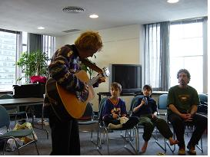
man, play

→ A man is playing a guitar.
The man is playing a musical instrument.
The young man is playing an instrument.
Some people are watching the man played a guitar.

[Question 4]
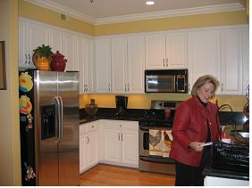
above, cabinet
→ The cabinets are above the kitchen counter.

[Question 5]
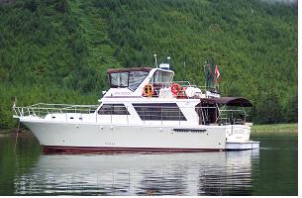
boat, on

→ The boat is floating on the water.

