< [ETS TOEIC Test] 김대균의 전략특강 – Lesson 1 >

[Part 1]

1. 2.


3. 4.
.  

5. 6.
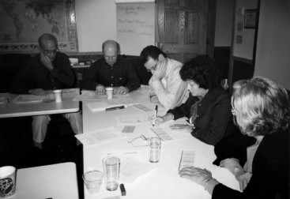

7. 8.


9. 10.


<김대균 특별제작 문제>

[Part 5]
1. It was when the dog __________ with his head bowed and tail tucked between his legs that I realized he was afraid of me.
(A) attempted
(B) contracted
(C) approached
(D) treaded

2. Her partially __________ sense of sight greatly hindered any ability to perform simple household tasks such as washing dishes or vacuuming the house.
(A) blind
(B) impaired
(C) strong
(D) keen

3. By improving her grade point average ____________ every semester, Martha was able to graduate from college with special honors.
(A) scholarly
(B) consecutively
(C) gravely
(D) analytically

4. In southern farms across the country, the ____________ exposure to dangerous chemicals and pesticides has shortened the lifespan of the farming community.
(A) cautious
(B) dubious
(C) impelled
(D) prolonged

5. Anyone who volunteers in this non-profit ____________ should have a strong commitment to improving the social welfare of inner-city families.
(A) organizer
(B) organizing
(C) organization
(D) organized

6. Rembrandt utilized shadows and blackness in his art and managed to convey __________ the feelings of trepidation many felt during his time.
(A) awkwardly
(B) stridently
(C) precisely
(D) frantically

7. The three objectives of this company are to provide the best quality care in customer service, to ___________ our knowledge and skills through teamwork, and to commit ourselves to achieving our goals and ambitions.
(A) belittle
(B) circumscribe
(C) pluralize
(D) broaden

8. She secured a new job right away but was disappointed to discover that pay was __________ with experience.
(A) transfer
(B) proposing
(C) commensurate
(D) valiant

< 정답 >

1. C
2. B
3. B
4. D
5. C
6. C
7. D
8. C

<목표! 어휘800>

- rack 옷걸이
- refer 위탁하다
- bestow 주다, 수여하다
- fairly 아주, 완전히
- precisely 정확하게, 꼼꼼하게
- memorable 기억할 만한, 잊혀지지 않는
- negligence 태만, 과실
- incorporate 통합하다, (프로그램을) 짜넣다
- unanimously 만장일치로
- strategy 전략, 기술
- commit 위탁하다, 맡기다
- execute 수행하다, 실행하다
- interim 임시의, 잠정의
- chopped 잘게 썬, 다진
- reimburse 변상하다, 배상하다
- handrail (계단) 손잡이, 난간
- estimate (비용) 견적
- coverage (방송) 보도
- fulfill 실행하다, 성취하다
- benefits 복리후생

※ 반으로 접어서 단어를 외우세요~

