< [ETS TOEIC Test] 김대균의 전략특강 – Lesson 21 >

[Part 1]

1.
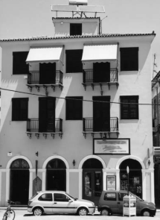

2.


3.


4.
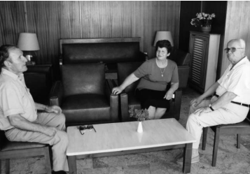

5.
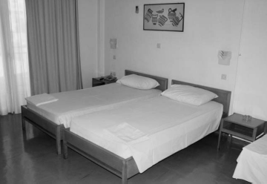
6.
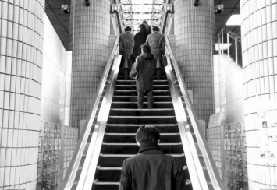
7.

8.
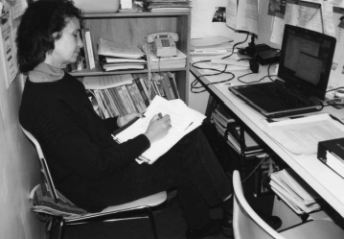
9.

10.


< 정답 >

1. D
2. B
3. A
4. C
5. D
6. C
7. D
8. B
9. A
10. B

<김대균 특별제작 문제>
[Part 5]

1. Our company’s policy prohibits extension of the rental period of any movies that are hugely _______, because other customers would be unable to rent them.
(A) diverse
(B) solicited
(C) popular
(D) acquainted

2. Employees ________ to submit formal requests if there is a planned change to their insurance policy.
(A) require
(B) requires
(C) is requiring
(D) are required

3. Aviation Control is hoping that ______ inspections of the runways will help in understanding the effects that weather has on them.
(A) frequent
(B) frequents
(C) frequently
(D) frequency

[Part 6]
Questions 4-7 refer to the following passage.
With InterPhone you no _____ need to pay unconscionable fees to speak with family, friends
4. (A) ever
(B) longer
(C) more
(D) further

or business associates in another part of the country or another part of the world. When you install this award-winning software your internet-connected computer equipped with headphones and microphone is _____into a free telephone.
5. (A) translated
(B) transposed
(C) transported
(D) transformed

Make totally free calls to anyone in the world who has InterPhone installed on his or her computer. If the person you wish to call does not have InterPhone or is not at their computer you can even make calls to their land line or mobile phone at rates far below those _____ by telephone companies.
6. (A) charges
(B) charged
(C) charging
(D) to charge

Objective tests conducted by independent laboratories show that sound quality on 90% of InterPhone calls surpasses that of conventional telephone calls. What’s more, all calls are automatically encrypted so privacy and security is _____ at all times.
7. (A) saved
(B) checked
(C) relieved
(D) assured

< 정답 >

1. C
2. D
3. A
4. B
5. D
6. B
7. D

<목표! 어휘800>

- landlord 집주인, 소유자
- depot 창고
- crude 천연 그대로의
- assumption 추즉, 가정
- friction 충돌, 마찰
- stagnation 침체, 불경기
- vomit 토하다
- retirement benefits 퇴직금
- limb 팔, 다리
- plunge 폭락하다
- commencement 학위수여식
- combine 합치다
- planetary 행성의, 세계적인
- cooperate 협력하다, 협동하다
- patron (예술가, 사업 등의) 후원자
- treasurer 회계원, 출납원
- brilliantly 훌륭하게
- inform A of B A에게B를 알려주다
- enterprise 회사, 기업, 사업
- expansion 확장, 확대, 증대

※ 반으로 접어서 단어를 외우세요~

