< [ETS TOEIC Test] 김대균의 전략특강 – Lesson 22 >

[Part 5]

101. Please contact Robert Chen for ------- in purchasing office equipment.
(A) store
(B) type
(C) help
(D) furniture

102. The awards ceremony will be ------- on the third floor of the Park Station Hotel.
(A) held
(B) raised
(C) taken
(D) granted

103. After Massey Corporation acquired Brawley, Ltd., the ------- of its stock rose twenty
percent.
(A) valuable
(B) valuate
(C) valued
(D) value

104. In March, the Grand Symphony Orchestra will present an ------- opera by talented
newcomer Maria Cruz.
(A) excite
(B) excites
(C) excited
(D) exciting

105. We hope to send ------- tax documents to you by the end of the week.
(A) you
(B) your
(C) yours
(D) yourself

106. All materials ------- for the upcoming seminar need to be copied at least two days
in advance.
(A) called
(B) required
(C) questioned
(D) invited

107. After the switch malfunction, electrical service on the main building was -------
restored at 8 P.M.
(A) finally
(B) constantly
(C) consecutively
(D) usually

108. Traveling by train to Tokyo takes approximately one hour less ------- traveling by car.
(A) for
(B) with
(C) as
(D) than

109. Because Hong Kong is home to people from all over the world, a ------- of
fashion styles can be seen in the city on any given day.
(A) variety
(B) kind
(C) separateness
(D) distance
110. Midtown Hospital compares ------- with other hospitals and provides services at
lower rates.
(A) favor
(B) favored
(C) favorable
(D) favorably

< 정답 >

101.C
102.A
103.D
104.D
105.B
106.B
107.A
108.D
109.A
110.D

<김대균 특별제작 문제 - 뉴토익 명강사 적중 400제>
[Part 1]

1.
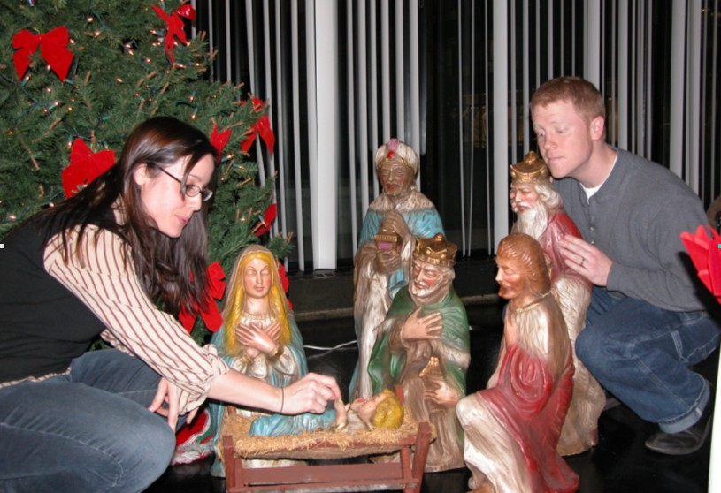

2.
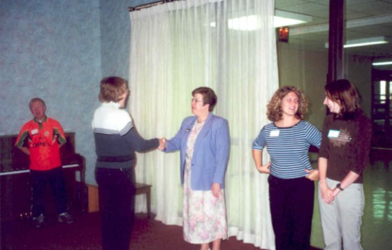

3.
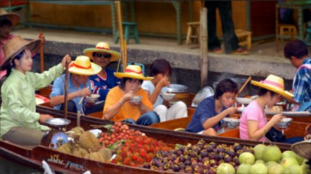
4.
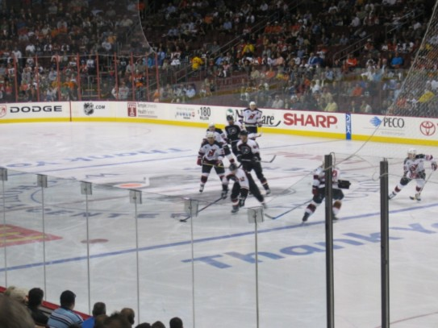
5.
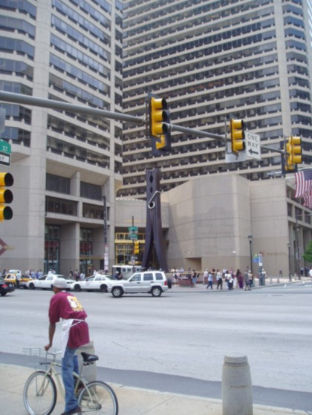

6.
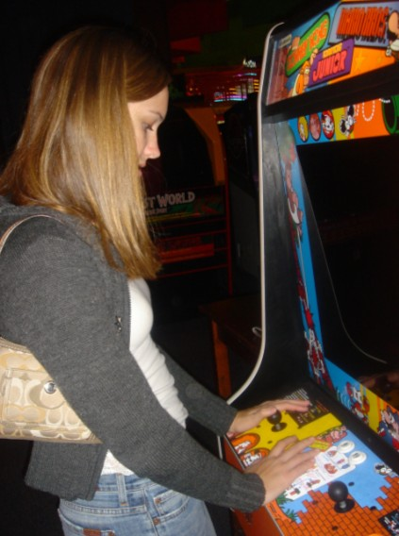

7.


8.
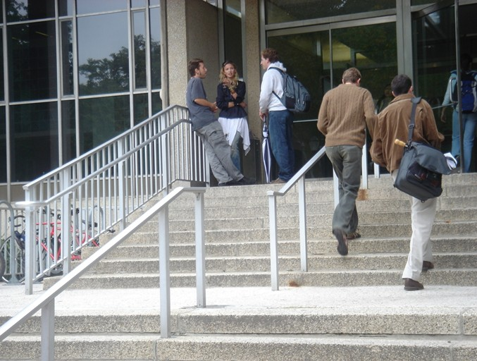
9.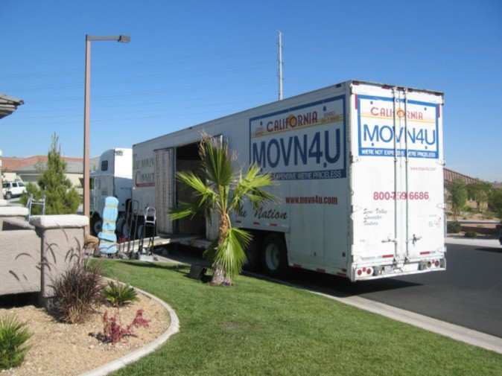

10.
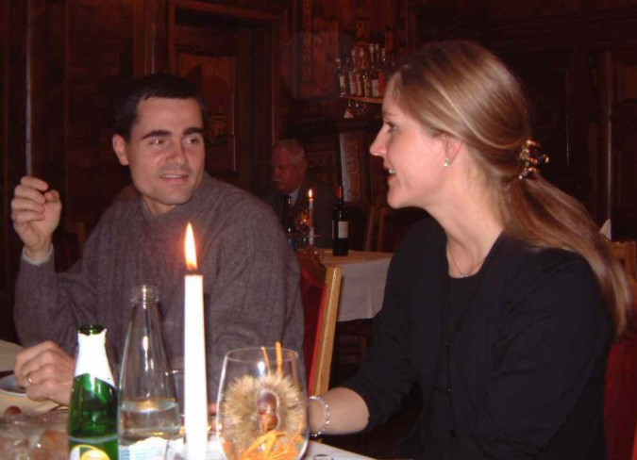

< 정답 >

1. B
2. A
3. D
4. C
5. A
6. B
7. D
8. A.
9. C
10. A

<목표! 어휘800>

- compatible 호환성이 있는
- dismiss 해임하다, 해고하다, 퇴학시키다, 해산시키다
- installment 할부, 할부금
- scenic 풍경의, 경치가 좋은
- be on strike 파업중이다
- oversize 특대의, 특대품
- bib 턱받이
- encase 케이스에 넣다, 상자에 넣다
- clash 충돌하다; 충돌
- draw 추첨
- attached 첨부한(된)
- warehouse 창고, 상품 보관소
- requisite 필수의; 필수조건
- confront 직면하다, 대항하다
- due date 지불 만기일
- shareholder 주주
- terms 조건, 조항
- eliminate 제거하다
- ignition 점화장치
- savings 저축(액)

※ 반으로 접어서 단어를 외우세요~

