< [ETS TOEIC Test] 김대균의 전략특강 – Lesson 32 >

[Part 7]

Questions 153-154 refer to the following e-mail message.

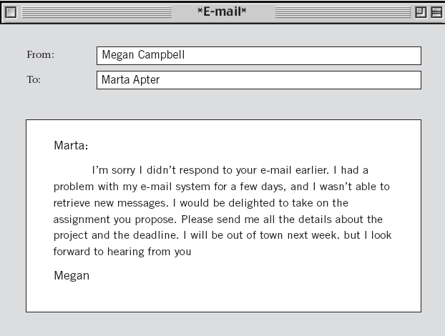

153. What is Megan’s main purpose in writing this e-mail?
(A) To apologize to Marta for not finishing an assignment
(B) To tell Marta she will accept an assignment
(C) To tell Marta she will be unable to complete an assignment on time
(D) To explain to Marta her problems with an assignment
154. Why did Megan not respond to Marta earlier?
(A) She needed to work on another project.
(B) She was not able to accept new work.
(C) She was out of town.
(D) She had a computer problem.

Questions 155-156 refer to the following letter.
Lamberts Bank
206 Rampton Hill
Thompson, WY 82073-3341

June 26

Mr. Michael Hunter

92 Woodvale Road
Wilton, WY 82007

Dear Mr. Hunter:

Your application for a bank account has been successful, and we are able to offer you the
following:
● Checkbook
● Check guarantee/debit card
● Use of Lamberts automatic teller machines (ATM’s) and CONNEX ATM’s
● Online banking and 24-hour telephone banking

A copy of the bank account conditions that apply to your account is enclosed.

Please deposit a minimum of $100 into your account. Once this has cleared, we will send your
check guarantee/debit card to you.
Thank you for your business.
Sincerely,

Jean Villiers
Jean Villiers (Ms.)
Accounts Manager

155. Why is the bank writing to Mr. Hunter?
(A) He lost his check book and check guarantee card.
(B) There are new charges to his account.
(C) He asked to open an account.
(D) He needed instructions for using the ATM’s.
156. What is Mr. Hunter asked to do after receiving the letter?
(A) Telephone the bank
(B) Register online
(C) Sign a contract
(D) Make a deposit

Questions 157-159 refer to the following letter.
Excelon Travel Services, Inc.
711 Market Street

San Francisco, California 94102

Dear Mr. Mirza:

Thank you for giving Excelon Travel Services the opportunity to arrange your family’s vacation travel plans. As an additional service to you, we have provided an overview of your travel and hotel
arrangements (all times are local):

Date Flight No. Place/Time Depart Place/Time Arrive
March 3 CM 045 San Francisco----8:40 A.M. Honolulu----10:50 A.M.
March 10 CM 1226 Honolulu----1:00 P.M. San Francisco----8:50 P.M.

Upon your arrival at Honolulu, your rental car will be waiting for you----just go to the Fritz Rentals service desk. As we discussed, room reservations have been made at the Mahalo Hotel; directions to the hotel will be available at the car rental desk.

We pride ourselves on over twenty years of providing the highest level of customer satisfaction and would very much appreciate your feedback on your experience with Excelon Travel Services. To help us continue to improve, please visit our Web site at www.excelonts.com and fill out our customer satisfaction survey.

Once again, thank you very much for your business.

Sincerely,

Janet S. Ono

Janet S. Ono
Customer Service Associate
Excelon Travel Services

157. Why will Mr. Mirza travel to Honolulu?
(A) To conduct a business transaction
(B) To attend a conference
(C) To set up a Web site
(D) To go on vacation with his family

158. Where will Mr. Mirza get directions?
(A) At the travel agency
(B) At the Fritz Rentals desk
(C) At the Mahalo Hotel
(D) At Excelon’s Web site

159. What does Ms. Ono ask Mr. Mirza to do?
(A) Call her when he gets to Honolulu
(B) Send payment as soon as possible
(C) Complete a survey
(D) Give her his e-mail address

Questions 160-162 refer to the following article.
£50m Print Works to Open

The city of Reading this week landed one of the biggest and most significant investments in the city in years---a £50m print works that promises 1,000 jobs. The Scorpia Group, one of Europe’s largest independent printing companies, has chosen a site on Compton Way for its new plant. This was the
former Hartland Steelworkslocation.

Local leaders are delighted at the prospect of hundreds of highly skilled jobs and training opportunities being created in the Reading area. Robert Andrews, chief executive of the Reading City Investment Initiatives said, “ The scale and nature of
this project will give a huge boost to the local economy.”

The printing plant will offer top-quality and fast color production of magazines, catalogs, and other publications. The Compton Way site is owned by Scorpia’s development partner, which was asked to draw up plans for the site. The company has chosen the Compton Way site on the basis of its location, the financial grants that are available from the central government, and the local labor market.

The chief executive of Scorpia said, “ The location of our new plant, with access to the road network and rail freight links, and the reputation of the workforce in the region had a big impact on our decision-making process. In addition, the attitude and cooperation of local authorities in Reading is a positive example to the rest of the
country of how to attract new investments.”

160. What is the article mainly about?
(A) Job openings at a steelworks factory
(B) Investment opportunities in Europe
(C) The proposed site of a new plant
(D) New laws enacted by the Reading City Council

161. What is NOT mentioned as a reason for choosing the location on Compton Way?
(A) It has good road and rail links.
(B) It has been enlarged recently.
(C) The government offers financial assistance.
(D) Plenty of labor is available locally.

162. Why does the head of Scorpia praise Reading’s local government?
(A) It has established strong ties with Europe.
(B) It cooperates with the local news reporters.
(C) It has encouraged development in the city.
(D) It offers financial aid to residents.

< 정답 >

153. B
154. D
155. C
156. D
157. D
158. B
159. C
160. C
161. B
162. C

<김대균 특별제작 문제 – 뉴토익 적중 400제>
[Part 3]

50. What did the man show the woman?
(A) His boarding pass.
(B) His passport.
(C) His receipt.
(D) His luggage.

51. What happened in the airport earlier in the day?
(A) Aircrews went on a strike.
(B) A few children were missing.
(C) Police caught a terrorist.
(D) Some flights departed late.

52. What is the man’s final destination?
(A) Paris.
(B) USA.
(C) Turkey.
(D) Ireland.

53. Where is the man’s wife?
(A) At a hospital.
(B) At home.
(C) In the office.
(D) In a car.
54. Why is the man excited?
(A) He has got a promotion.
(B) His wife is going to have a baby.
(C) His presentation was very successful.
(D) He received a parcel from his wife.

55. Who will do the presentation this afternoon?
(A) Nancy.
(B) Don.
(C) Don’s wife.
(D) Nancy’s doctor.

56. Where does this conversation take place?
(A) A restaurant.
(B) A coffee shop
(C) A hair salon.
(D) A clothing store.

57. What time of the day is this conversation taking place?
(A) Morning.
(B) Afternoon.
(C) Evening.
(D) Late night.

58. How many things does the woman want done?
(A) One.
(B) Two.
(C) Three.
(D) Five.

< 정답 >

50. A
51. D
52. C
53. A
54. B
55. A
56. C
57. B
58. B

<목표! 어휘800>

- stop by 들르다, 방문하다
- advertise 광고하다, 선전하다
- detention 구류, 감금
- working unit 근무조
- monument 기념비, 유적
- donate 기증하다
- wreck 난파, 충돌
- debate 논의하다; 토론
- attain 달성하다, 얻다
- varsity 대표팀
- incentive 동기, 자극
- registration 등록
- roommate 룸메이트, 동거인
- tailor-made 맞춤의
- bleak 몹시 추운, 혹독한
- art museum 미술관
- courier 배달원
- savings account 보통예금
- bookkeeping 부기, 회계장부를 기입하다
- component 부품, 성분

※ 반으로 접어서 단어를 외우세요~

